**Augmented Reality Based Scanner**

**UCS 503**

**Software Engineering**

Submitted by

101783039 – Shivam Bhushan

101603316 – Shivam Mittal

101610081 – Satwik Tripathi

101610082 – Shagun Kaushal

B.E Third Year, Computer Engineering

Submitted to

Dr. Sanmeet Bhatia



Thapar Institute of Engineering and Technology

November 2018

**UCS 503**

**Software Engineering, BE 3rd Year**

**Contents Page No**

1. **Introduction**
   1. Scope Definition 3
   2. Block Diagram of Project 3
   3. Ishikawa Diagram of Problem Formulated 4
2. **Analysis Phase**
   1. Use case Diagram based on Use Case Scenario 5
   2. Activity Diagram 6
   3. Data flow Diagrams 6
   4. Software Requirement Specifications (separate document)
3. **Design Phase**
   1. Class diagram 9
   2. Collaboration Diagram 10
   3. Sequence Diagram 10
   4. State Chart Diagram 11
4. **Deployment Phase**
   1. Component Diagram 12
   2. Deployment Diagram 13

**Introduction**

* 1. **Scope Definition**

Augmented Reality Based Framework is an augmented reality based application project that has the purpose of scanning the surroundings through a camera and projecting an image that can act as a guide cum virtual projection of the surrounding. We plan to implement these functionalities for an audience of Thapar university students and staff members.

The AR Scanner System is to be implemented in the following three phases:

1. Pilot Phase: Here the AR scanner including access control will be implemented at the university level. Initially we will be providing access privileges for three types of users: Students, Staff and Admin as they will be ones most involved in this phase.

2. Institute wise deployment: Following the successful completion of the pilot phase, we plan to deploy the same across city and functionalities of AR Navigation and Art Draw will be implemented.

3. Extension of AR Scanner system to other applications: In the future we can have train our project using computer vision to give information about the objects scanned.

* 1. **Block Diagram of the Project**

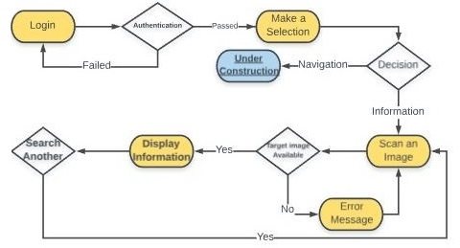

* 1. **Ishikawa Diagram of the problem formulated**

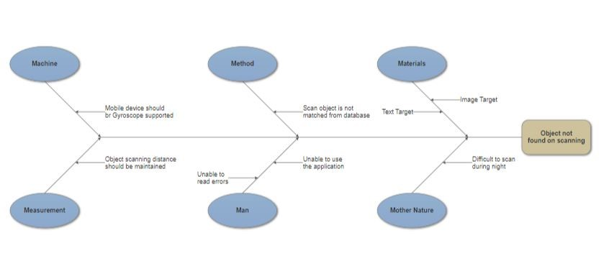

**Analysis Phase**

* 1. **Use Case Diagram**

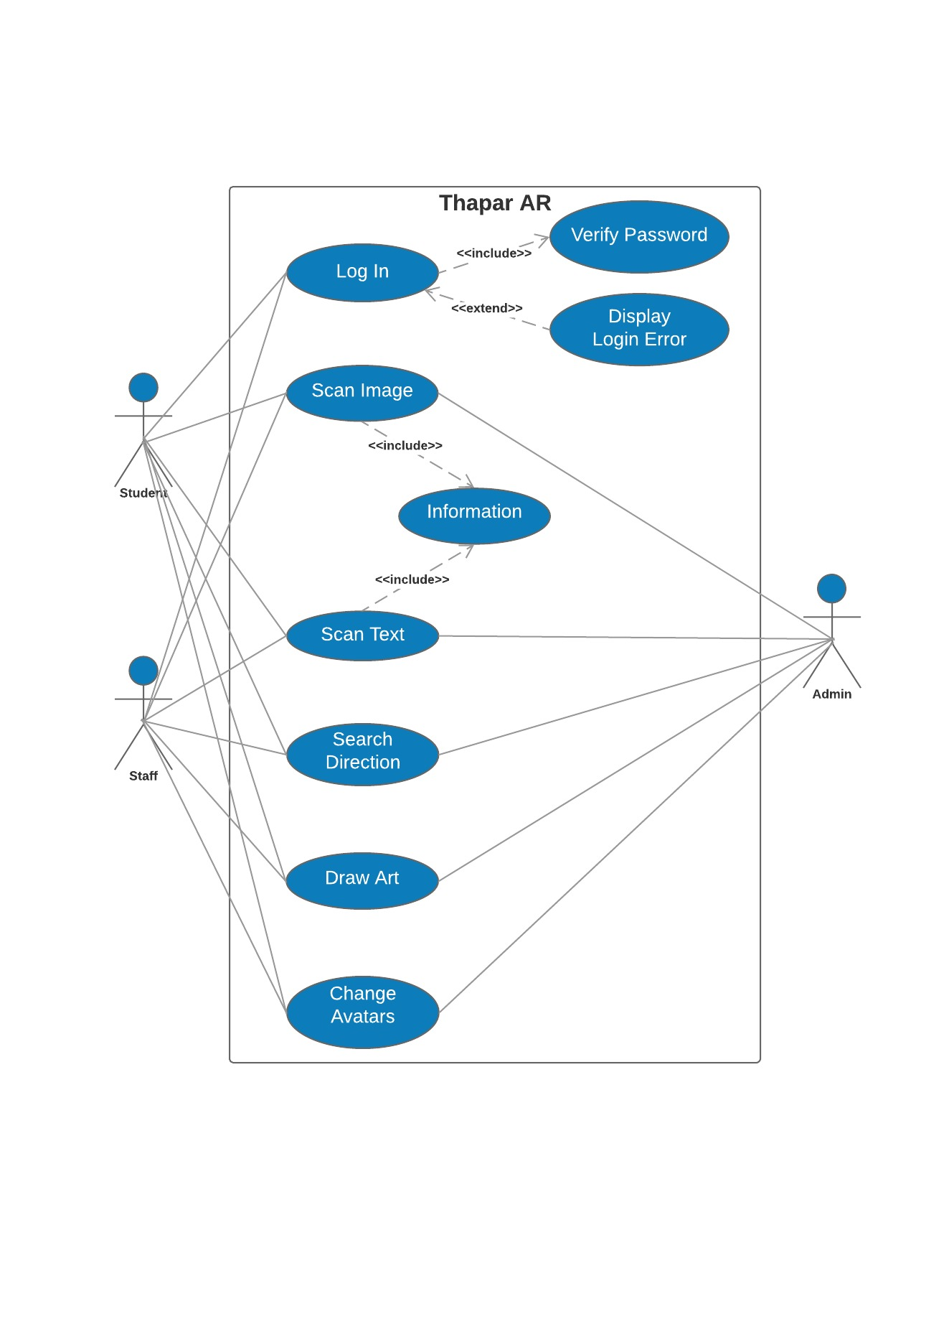

* 1. **Activity Diagram**

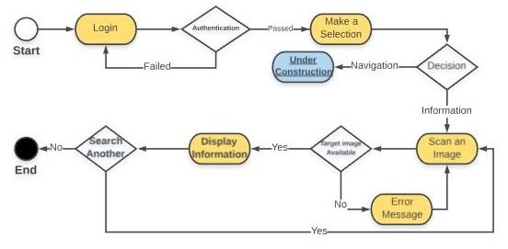

* 1. **Data Flow Diagram**

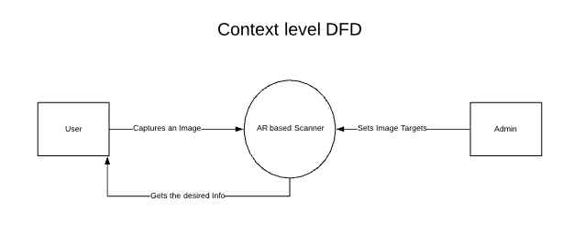

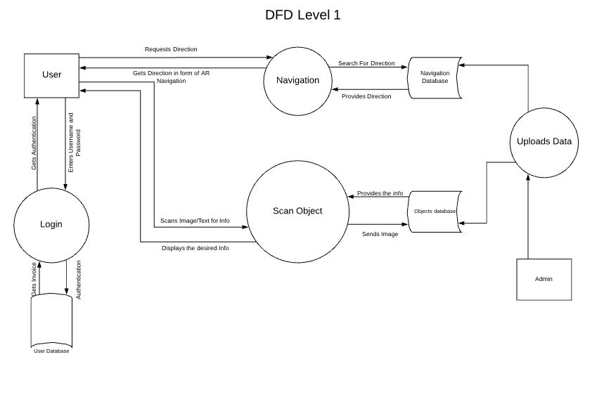

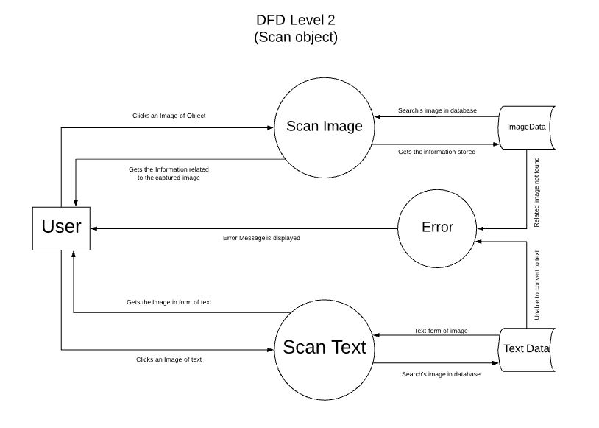

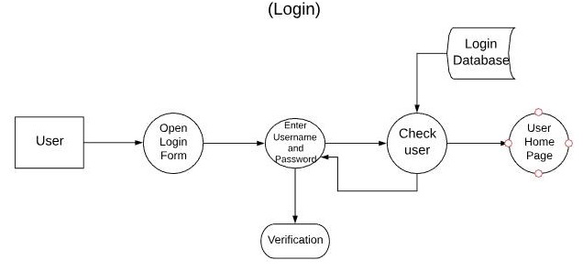

**Design Phase**

**3.1 Class Diagram**

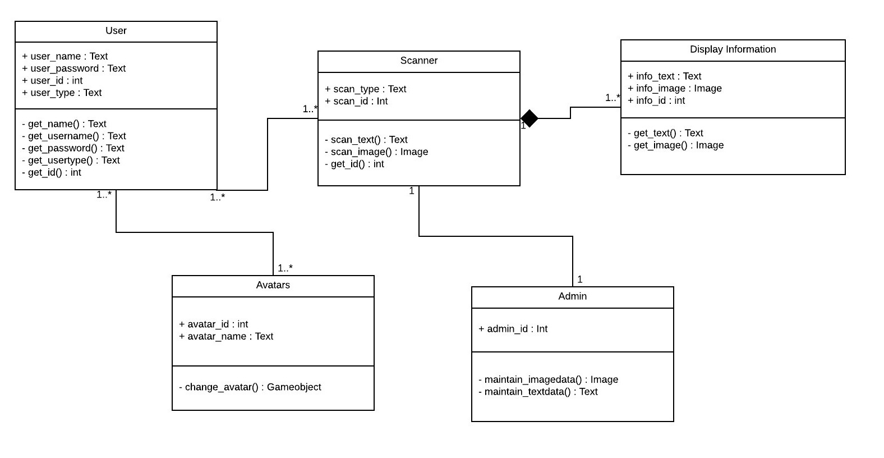

**3.2 Collaboration Diagram**

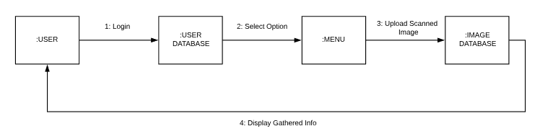

**3.3 Sequence Diagram**

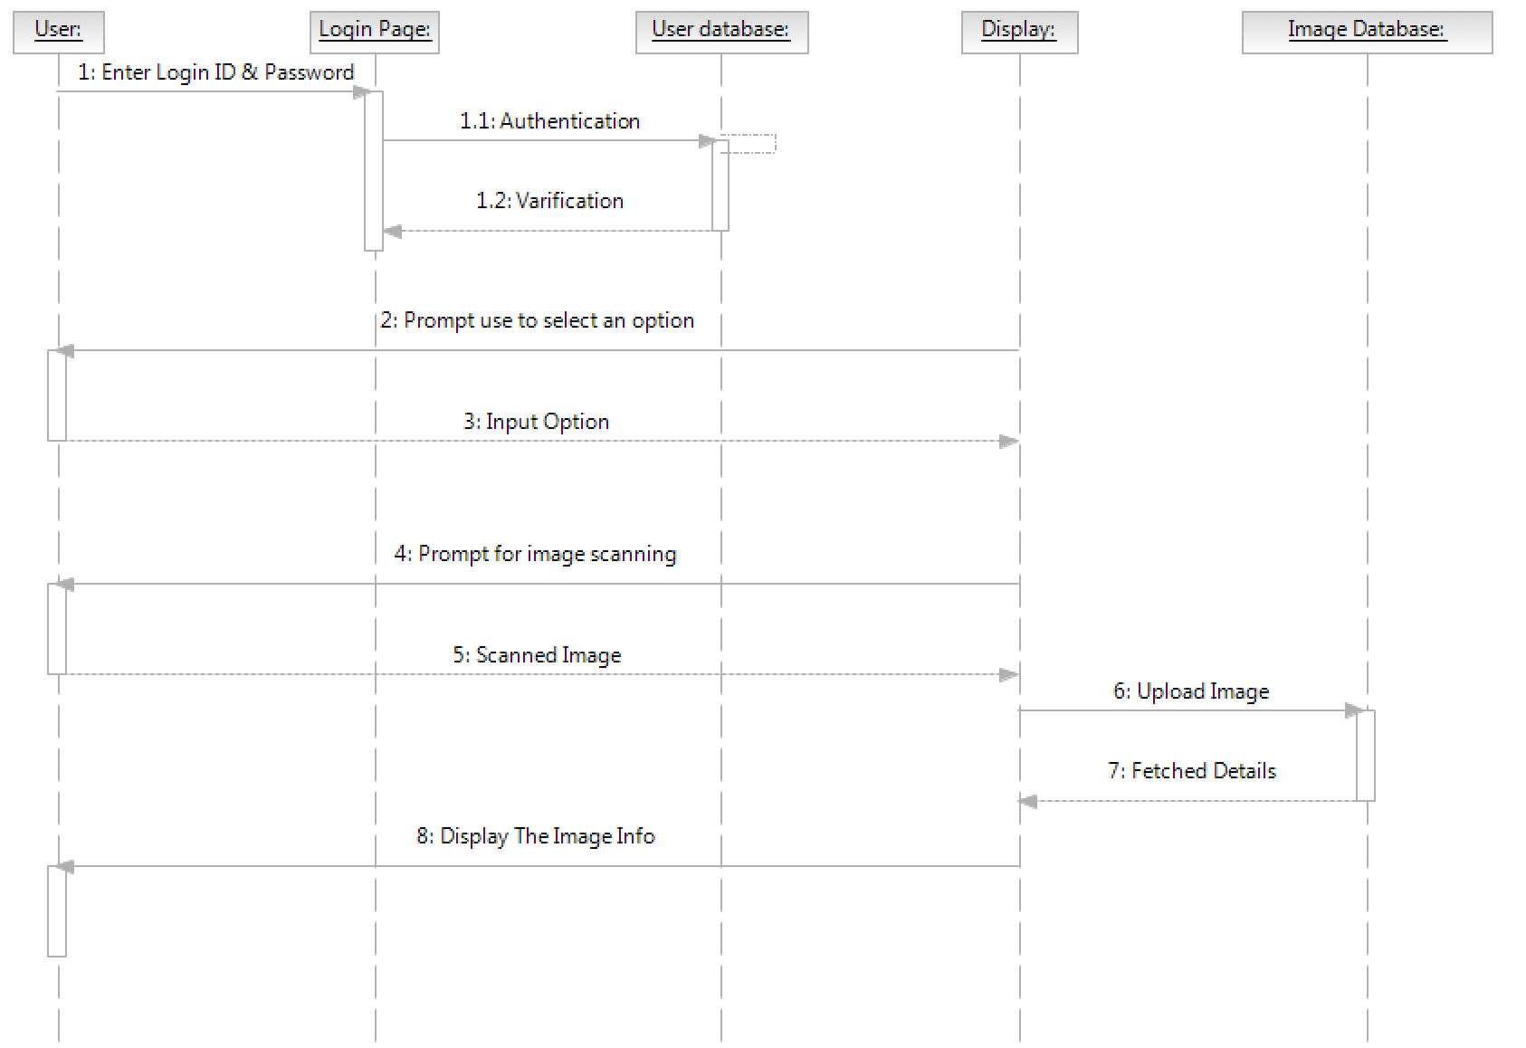

**3.4 State Chart Diagram**

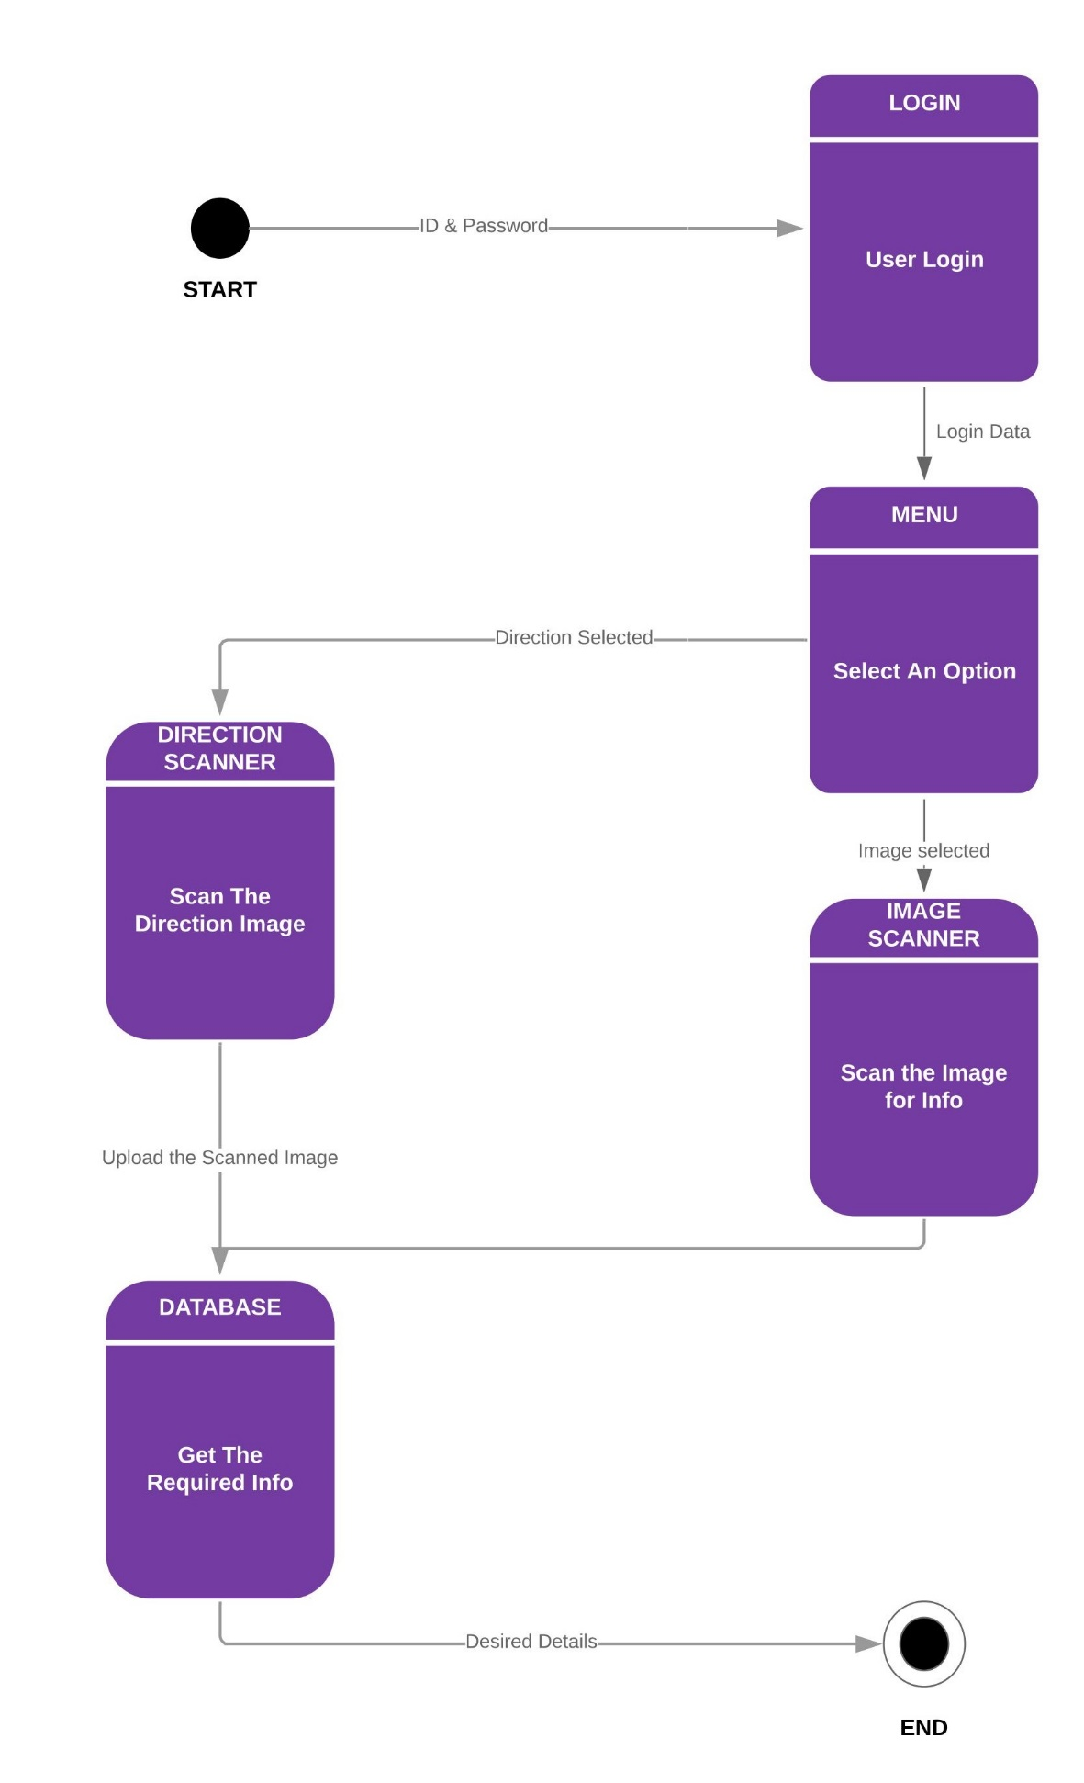

**Deployment Phase**

* 1. **Component Diagram**

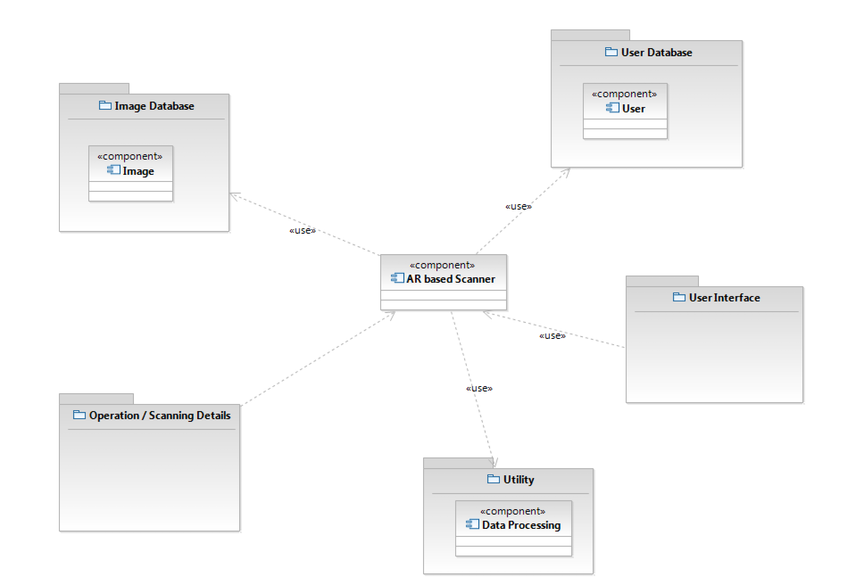

* 1. **Deployment Diagram**

